Exam-Style Questions for Chapter III

1.Explain two consequences of illegal Israeli settlements in the West Bank (8 marks)
2.Write a narrative account analysing the key events that led to Israel imposing a blockade on Gaza in June 2007 (8 marks)
3.Explain two of the following:
The consequences of the blockade on Gaza
How life differs for Palestinians and Israelis inside Israel
The value of comparison when discussing Palestine-Israel (with reference to apartheid) (16 marks)

What should be done about the situation in Palestine-Israel?

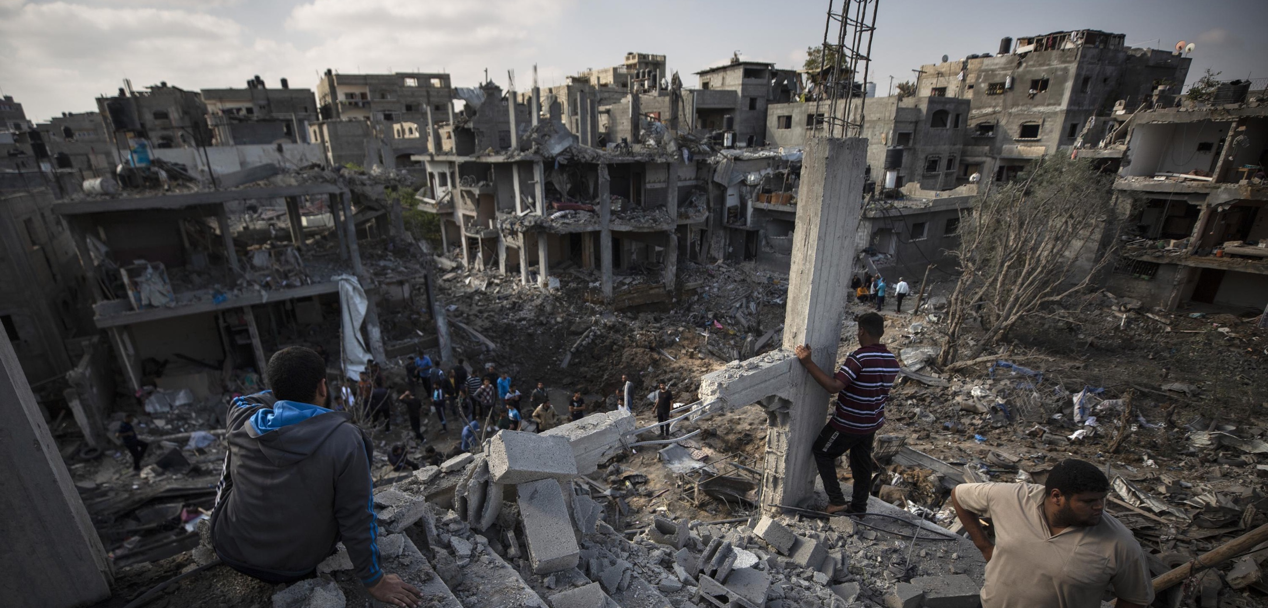

By the end of this lesson, you should be able to:

Describe the main changes over time in Palestine-Israel
Explain the main changes over time in Palestine-Israel
Suggest what should be done about the situation in Palestine-Israel

Chapter 1 Recap

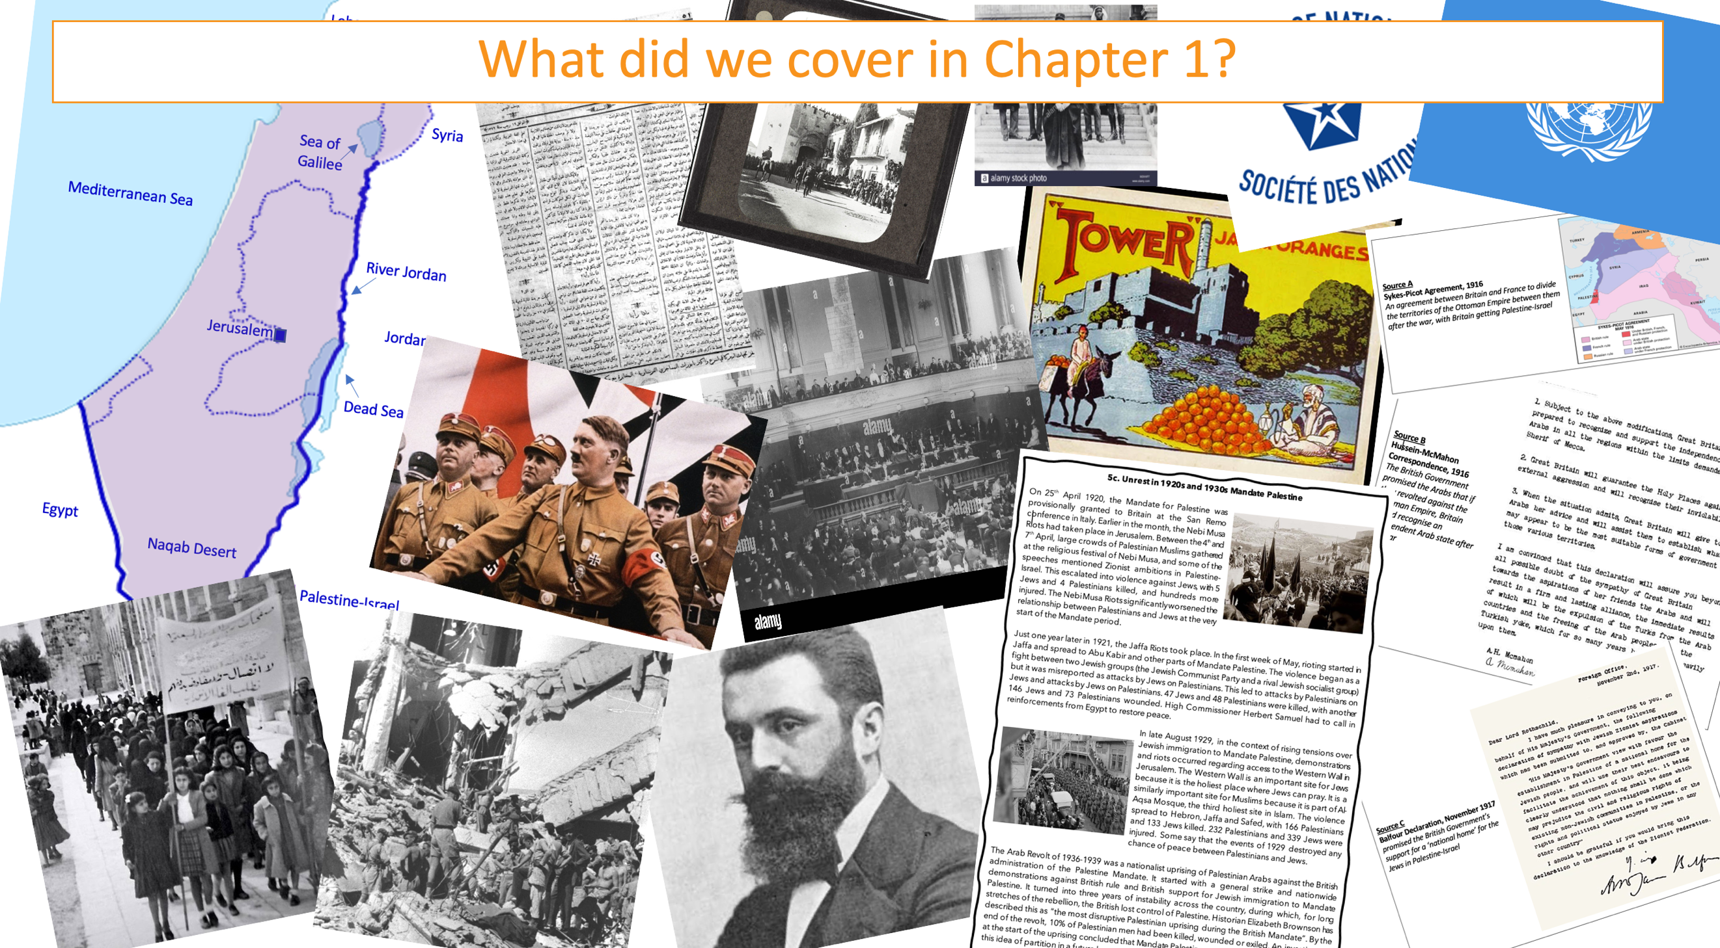

Chapter 2 Recap

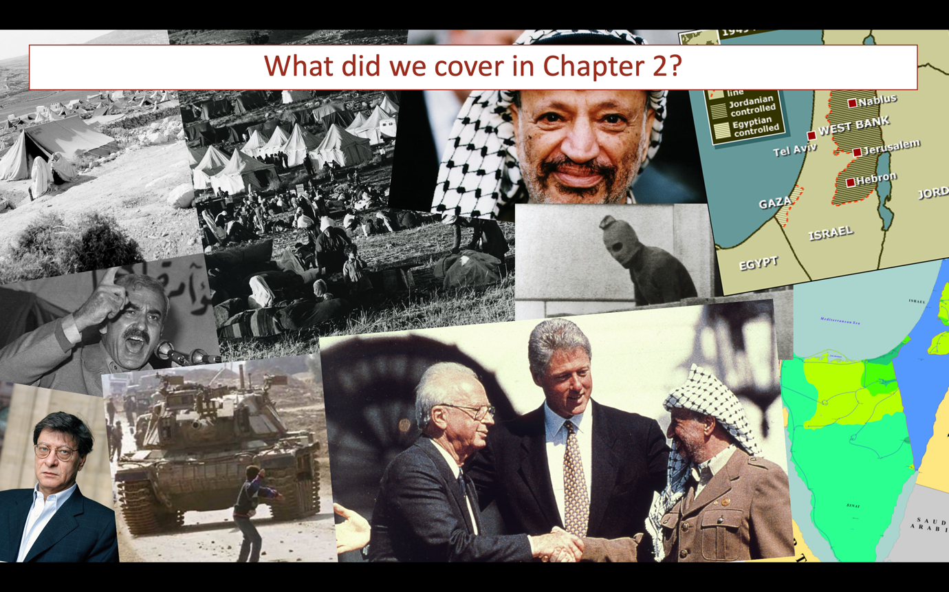

Chapter 3 Recap

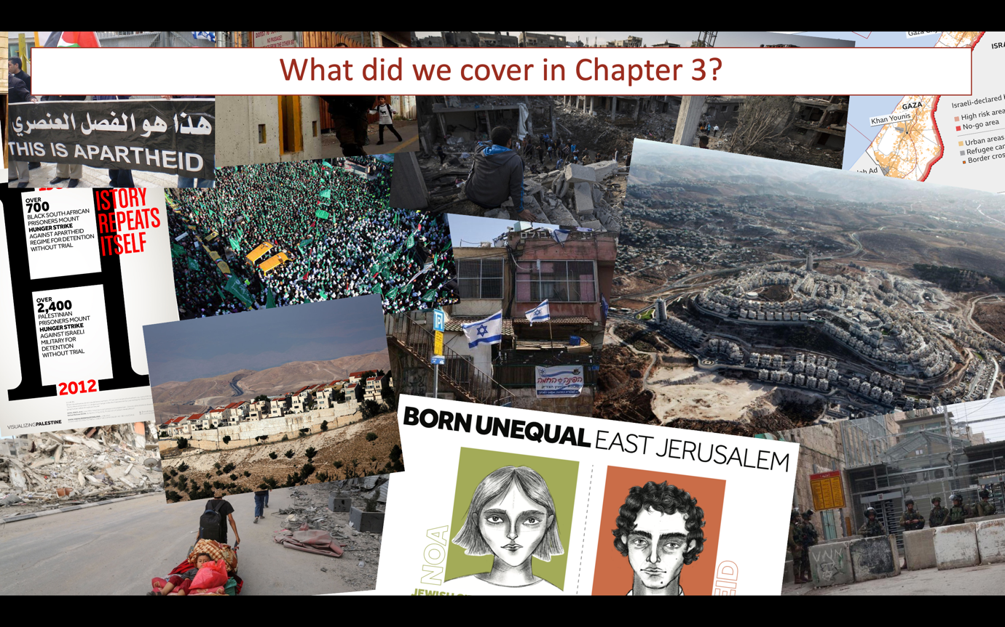

Timeline of events in Palestine-Israel

1800s: Palestine becomes modernised as part of the Ottoman Empire

1897: The Zionist movement emerges and holds its first congress

1914-1918: The Ottoman Empire falls apart during WWI

2nd November 1917: Balfour promises British support for a ‘national home’ for Jews in Palestine

Early 1920s: Britain is given a ‘Mandate’ to govern Palestine by the League of Nations

November 1947: Britain is to leave Palestine and the UN votes that Palestine will be partitioned into Israel and Palestine

1948: The Nakba takes place and 750,000 Palestinians are forced to leave their homes

14th May 1948: The state of Israel is established, and the rest of Palestine is now governed by Jordan and Egypt

1967: A six-day war takes place between Israel, Egypt, Jordan and Syria. As a result, Israel occupies all of historic Palestine

1980: Israel illegally annexes East Jerusalem

1987-1993: A massive uprising of Palestinians against Israeli occupation takes place, known as the First Intifada

1993 & 1995: Israel and the PLO agree to work together to achieve peace in the Oslo Accords but they fail

2000-2005: Another massive Palestinian uprising occurs, known as the Second Intifada

2007: Following the 2006 Palestine election, Israel imposes an air, land and sea blockade on Gaza

2021 -2022: Leading international human rights organisations report that Israel is committing the crime of apartheid against Palestinians

Questions

What is missing from this timeline?
Hint: what has happened in Gaza since 2007?

What is the most significant event(s) on this timeline? Why?

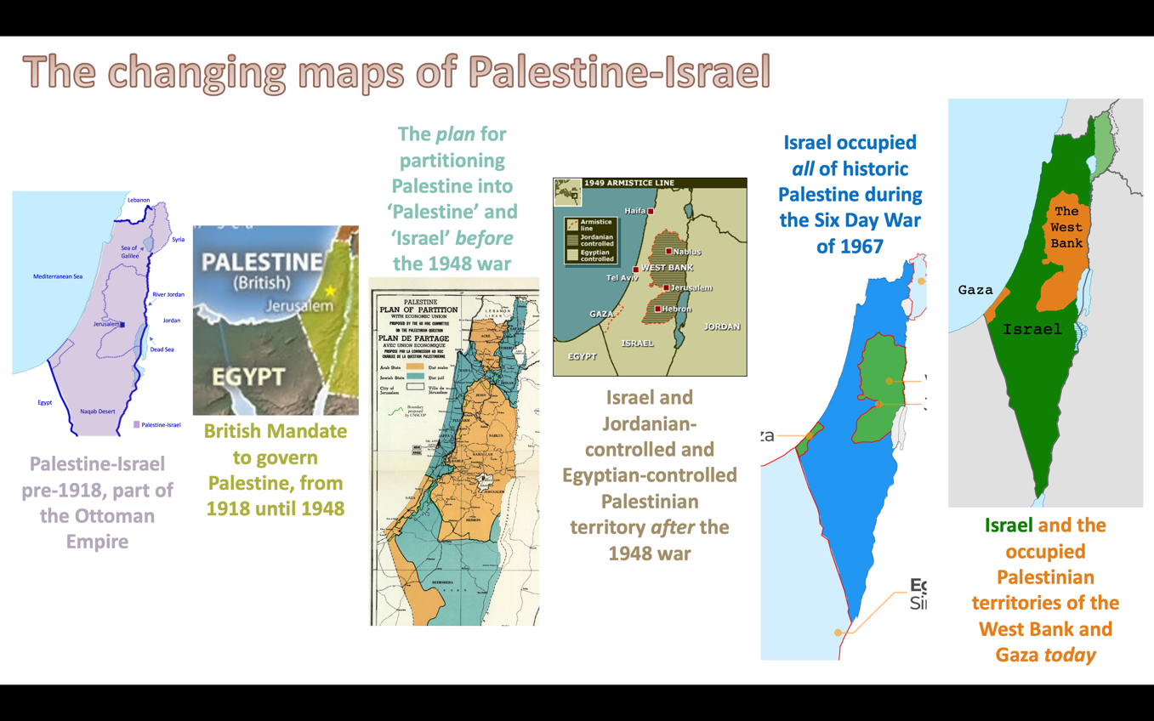

Activity

Using the information above, describe 2-3 differences between Palestine-Israel in the past and today.

Why have these changes occurred?

Write a paragraph describing and explaining each change you have identified.

Activity: True or false?
In Lesson 1, you wrote ‘true’ or ‘false’ under each of these statements.
If you did the same again now, how would your answers be different? Why?
Write down each of these statements. Underneath each statement, write a sentence or two about whether your answer would be similar or different to before.
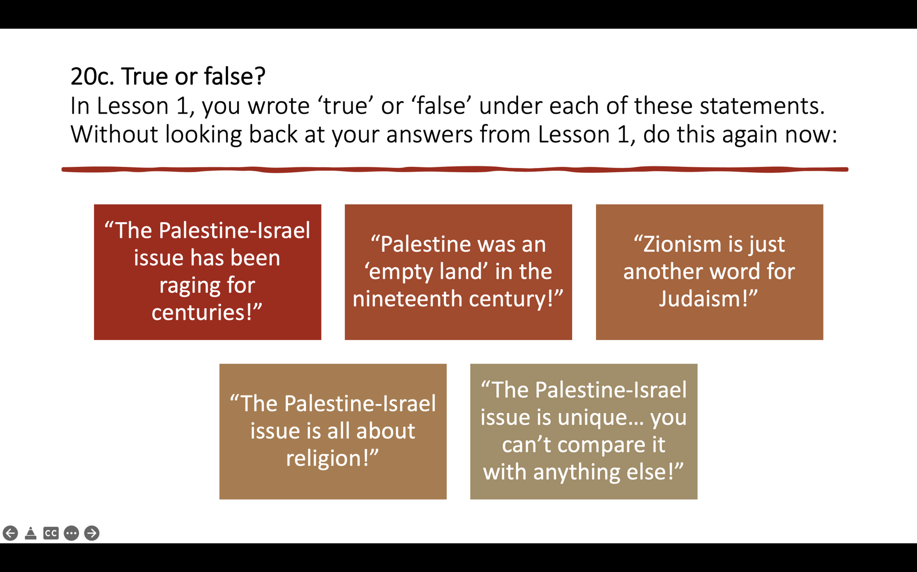

Activity: Myth vs. reality
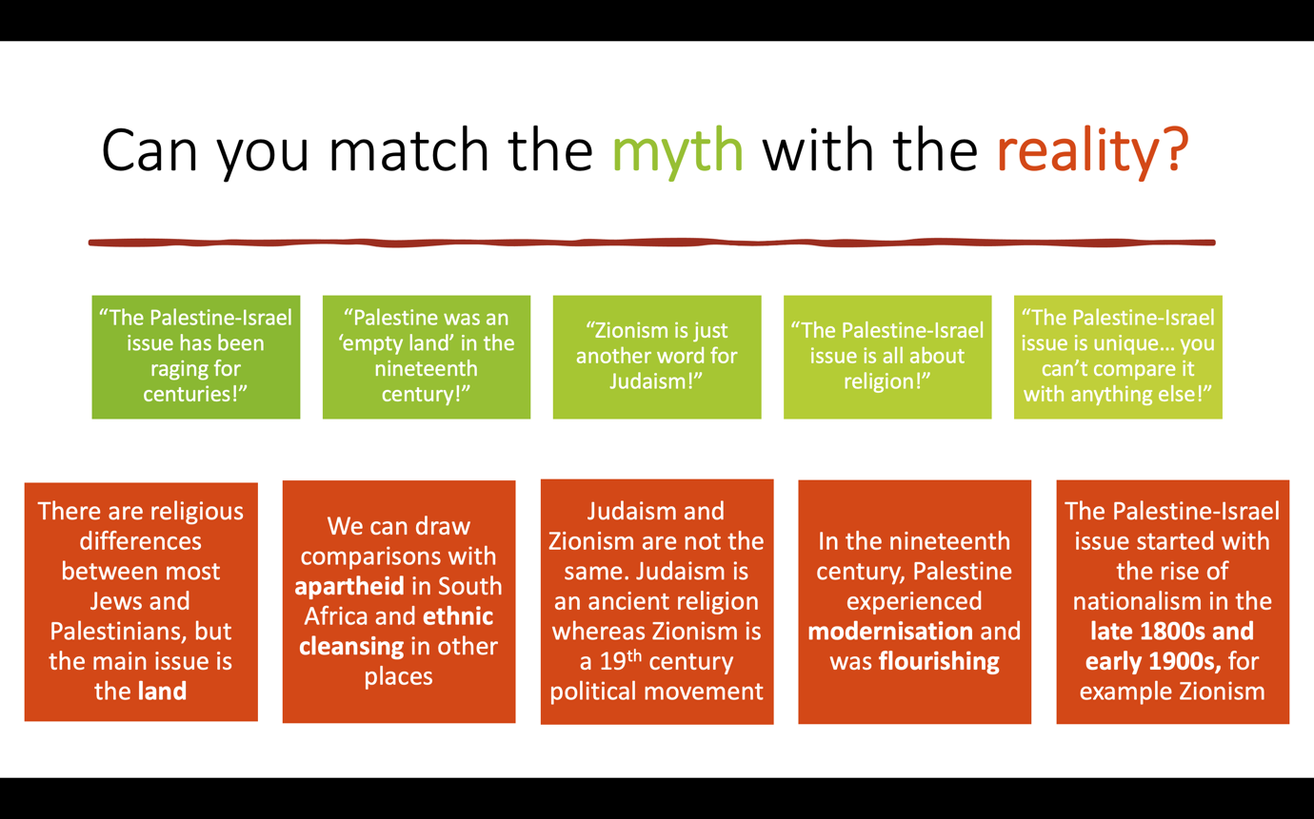

Questions

1.What are the main barriers to peace, justice and equality in Palestine-Israel?
2.What can be done to reduce these barriers?
3.What should we do about the situation in Palestine-Israel?

